**Design Document**

**E-PROJECT:whoZThat**

whoZThat

|  |  |  |
| --- | --- | --- |
| **SUPERVISOR** | **TAHA ABBAS ALI** | |
| **BATCH CODE** | **2501B2** | |
| **GROUP** | B | |
| **SERIAL NO** | **ENROLLMENT NUMBER** | **STUDENT NAME** |
| **1** | Student1633780 | Abdullah |
| **2** | Student1636167 | Abdullah Azaam |

**E-PROJECT: whoZThat**

**Problem Statement:**

A biography is a detailed description of a person's life. It involves more than just the basic facts like education, work, relationships, and death; it portrays a person's experience of these life events. Unlike a profile or [curriculum vitae](https://en.wikipedia.org/wiki/Curriculum_vitae) ([résumé](https://en.wikipedia.org/wiki/R%C3%A9sum%C3%A9)), a biography presents a subject's life story, highlighting various aspects of their life, including intimate details of experience, and may include an analysis of the subject's personality.

You need to develop a biography of any Nobel prize winner in science genre.

**Functional requirement specification :**

The Web site is to be created based on the following requirements.

1. The Home Page should be created making use of Sections with a suitable logo, the header section can be added which will show images chairs.
2. The site must contain the links to navigate through any category for the information.
3. The site should include the complete personal details about the respective person
4. User should also be able to get the glimpse of education and carrier.
5. There should be carrier graph and struggle of the person
6. One should be able to get to know the complete details about the achievements.
7. There should also be a section that includes the details specifying research/experiment for which Nobel prize was awarded.
8. There should be a section where one can get to know the available books related to him/her
9. A brief summary of about the research should be available on the Website which can be downloaded by the User who wishes to.

**E-PROJECT: whoZThat**

**Acknowledgements:**

We would like to extend our heartfelt gratitude to all those who made *whoZThat* possible. This website is the result of collaborative effort, curiosity, and a passion for storytelling through the lives of remarkable individuals.

Special thanks to the researchers, writers, and editors whose dedication ensured the accuracy and depth of each biography. We are also grateful to our web development team for bringing the project to life with thoughtful design and seamless functionality.

We sincerely appreciate the contributions of the historians, educators, and institutions that provided valuable resources and insights. Their support has been instrumental in shaping the content and credibility of *whoZThat*.

Finally, we thank our visitors and readers. Your interest and engagement inspire us to continue sharing stories that deserve to be remembered.

With gratitude,  
The *whoZThat* Team

**E-PROJECT: whoZThat**

**Synopsis:**

**Introduction:**

*whoZThat* is an educational and informative website dedicated to exploring the lives of influential personalities from various fields including science, literature, politics, art, and more. The platform aims to provide well-researched, accessible, and engaging biographical content that highlights key life events, achievements, and contributions of notable individuals. Whether you're a student, educator, or a curious mind, *whoZThat* serves as a gateway to understanding the people who shaped our world.

Each profile goes beyond just dates and facts — it tells a story. From early life to major milestones, and from career highlights to global impact, the biographies are structured to provide a comprehensive yet concise view of each individual’s journey.

**User Interface:**

The *whoZThat* website features a clean, intuitive, and responsive design that ensures a seamless user experience across all devices — mobile, tablet, and desktop. The homepage offers categorized navigation (e.g., by profession, era, nationality) to help users discover new biographies with ease.

Each biography page is organized into well-defined sections such as:

**E-PROJECT: whoZThat**

* **Personal Details**
* **Career Highlights**
* **Education**
* **Achievements & Awards**
* **Related Books & Resources**

A search function and filter options allow users to quickly find specific individuals or topics of interest. The minimalist design emphasizes readability and user engagement, with smooth transitions and clear calls to action.

Whether browsing casually or conducting in-depth research, *whoZThat* is built to make learning about great lives both simple and inspiring.

**Conclusion:**

*whoZThat* is more than just a collection of biographies — it’s a celebration of human potential, perseverance, and impact. By offering well-organized, factual, and engaging content, the platform aspires to educate, inspire, and spark curiosity in learners of all ages.

With its user-friendly interface and thoughtfully structured information, *whoZThat* makes it easy to explore the stories of those who have shaped

**E-PROJECT: whoZThat**

history and continue to influence the present. As we continue to grow and add more remarkable individuals to our archive, our mission remains the same: to keep their legacies alive and accessible to everyone.

Whether you're here to discover, research, or simply be inspired — welcome to *whoZThat*, where every story matters.

**E-PROJECT: whoZThat**

Sitemap of navbar :

**E-PROJECT: whoZThat**

**Task sheet review :**

|  |  |  |  |  |  |  |
| --- | --- | --- | --- | --- | --- | --- |
| **TOPICS** | | **PROJECT TITLE** | **DATE OF PREPARATION OF ACTIVITY PLAN** | | | |
| **No**  **.** | **Task** |  | **ACTUAL** | **ACTUAL** | **NAME** | **STATUS** |
| **START DAY** | **DAYS** |
| **1** | Deciding the structure and content for the website | whoZThat | **03-may-2025** | **3** | **Abdullah,**  **Abdullah azaam** | **complete** |
| **2** | Navbar, Footer  and logo designing  Build Home Page | whoZThat | **07-may-2025** | **2** | **Abdullah,**  **Abdullah azaam** | **complete** |
| **3** | Feedback  form | whoZThat | **10-may-2025** | **1** | **Abdullah azaam** | **complete** |
| **4** | Documentation of  website  Developer guide  User guide  Design Document | whoZThat | **11-may-2025** | **3** | **Abdullah** | **complete** |
| **5** | Final Checking of  the website | whoZThat | **15-may-2025** | **1** | **Aznaan javed** | **complete** |
| **6** | Video clip  demonstrating the  working of your  Project. | whoZThat | **17-may-2025** | **1** | **Abdullah azaam** | **complete** |

**E-PROJECT: whoZThat**

**Summary :**

whoZThat is a biography-focused website that showcases the lives and achievements of notable individuals from various fields such as science, literature, politics, and the arts. Designed for students, educators, and curious minds, the site offers well-researched, easy-to-read profiles organized into sections like personal details, career, education, awards, and more. With a clean, responsive interface and searchable categories, *whoZThat* makes it simple to explore and learn about influential figures who have shaped history and continue to inspire the world today.

**Our Vision :**

At *whoZThat*, our vision is to become a leading digital platform that preserves and shares the stories of remarkable individuals from all walks of life. We aim to ignite curiosity, promote learning, and inspire future generations by making biographical knowledge accessible, engaging, and meaningful. Through thoughtful storytelling and innovative technology, we strive to connect people with the lives that have shaped our world — one biography at a time.

**E-PROJECT: whoZThat**

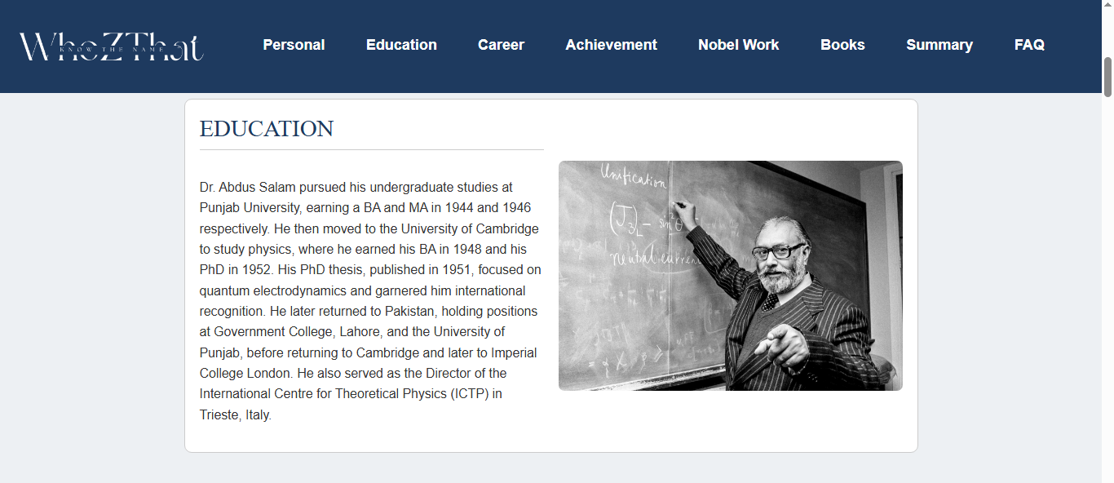

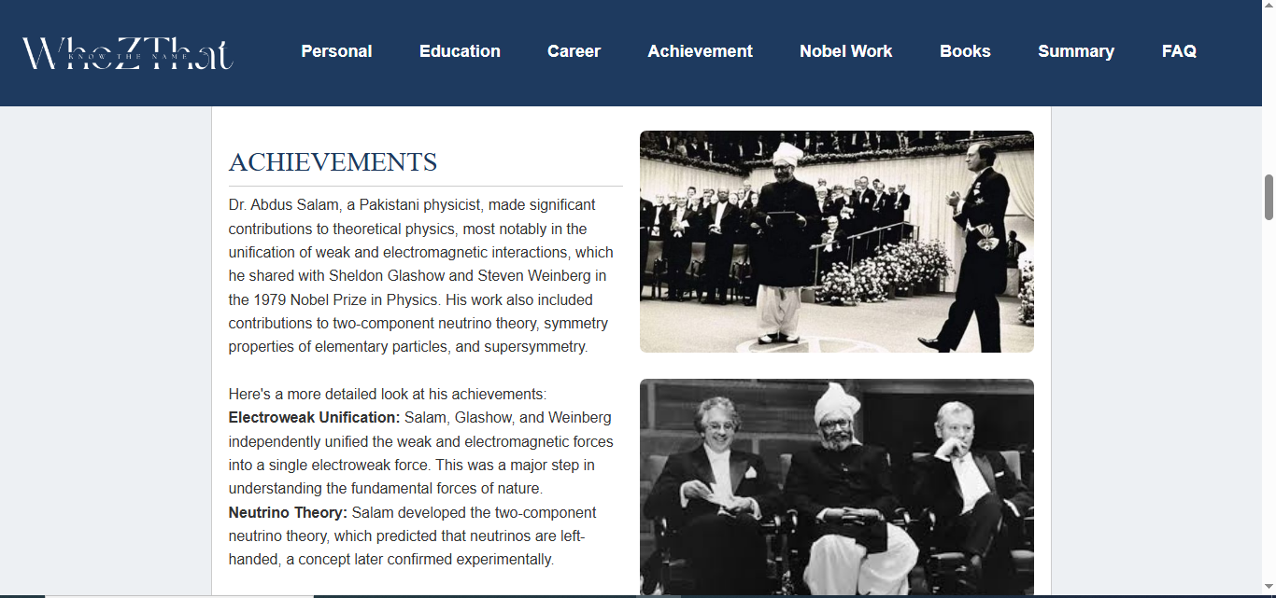

**E-PROJECT: whoZThat**

